

Patient dashboard



Website Link: https://patient-dashboard-streamlit.herokuapp.com/

APRIL 30, 2022


PATIENT DASHBOARD

Project Exhibition -II

Submitted in partial fulfillment for the award of the degree of

Bachelor of Technology In
COMPUTER SCIENCE AND ENGINEERING

Submitted to

VIT BHOPAL UNIVERSITY (M.P.)

Submitted by

ABHISHEK THAPLIYAL 20BCE10231
NIMISH SARATHE 20BCE10881
UTKARSH KUMAR 20BCE10622
BHARTI GATTANI 20BCE10506
NIKHIL KUMAR DAS 20BCE10712

Under the Supervision of

Prof. VIKAS PANTHI

SCHOOL OF COMPUTER SCIENCE ENGINEERING

VIT BHOPAL UNIVERSITY
BHOPAL (M.P.)-466114
APRIL-2022

A PROJECT REPORT

Submitted by

ABHISHEK THAPLIYAL 20BCE10231
NIMISH SARATHE 20BCE10881
UTKARSH KUMAR 20BCE10622
BHARTI GATTANI 20BCE10506
NIKHIL KUMAR DAS 20BCE10712

in partial fulfillment for the award of the degree
of

BACHELOR OF TECHNOLOGY

in

COMPUTER SCIENCE AND ENGINEERING

SCHOOL OF COMPUTING SCIENCE AND ENGINEERING
VIT BHOPAL UNIVERSITY
KOTHRIKALAN, SEHORE
MADHYA PRADESH – 466114
April- 2022

VIT BHOPAL UNIVERSITY, KOTHRIKALAN, SEHORE
MADHYA PRADESH – 466114

BONAFIDE CERTIFICATE

Certified that this project report titled “PATIENT DASHBOARD” is the bonafide work of “ABHISHEK THAPLIYAL (20BCE10231), NIMISH SARATHE (20BCE10881) ,UTKARSH KUMAR (20BCE10622) ,BHARTI GATTANI (20BCE10506) ,NIKHIL KUMAR DAS (20BCE10712)” who carried out the project work under my supervision. Certified further that to the best of our knowledge the work reported at this time does not form part of any other project/research work based on which a degree or award was conferred on an earlier occasion on this or any other candidate.

PROGRAM CHAIR PROJECT GUIDE

Dr. Sandip Mal Mr. Vikas Panthi
School of Computer Science and School of Computer Science and
Engineering Engineering

VIT BHOPAL UNIVERSITY VIT BHOPAL UNIVERSITY

The Project Exhibition II Examination is held on _23rd APRIL,2022_

ACKNOWLEDGEMENT

First and foremost, I would like to thank the Lord Almighty for His presence and immense blessings throughout the project work.
I wish to express my heartfelt gratitude to Dr. Sandip Mal, Head of the Department, School of Aeronautical Science for much of his valuable support encouragement in carrying out this work.
I would like to thank my internal guide Mr. Vikas Panthi, for continually guiding and actively participating in my project, giving valuable suggestions to complete the project work.
I would like to thank all the technical and teaching staff of the School of Aeronautical Science, who extended directly or indirectly all support.
Last, but not least, I am deeply indebted to my parents who have been the greatest support while I worked day and night for the project to make it a success.

List of Symbols & Abbreviations

PD:-  KPI’s:-  IoT:-  GUI:- | Patient Dashboard  Key Performance Indicators  Internet of Things  Graphical User Interface
I/O:- | Input/output
&:- | And
IDE:- | Integrated development environment
LAN:- | Local Area Network
FPS:- | Frames Per Second
CPU:- | Central Processing Unit
RAM:- | Random-access memory
GPU:- | Graphics Processing Unit

LIST OF FIGURES AND GRAPHS

FIGURE NO. | TITLE | PAGE NO.
1 | Flow Diagram-1 | 24
2 | Flow Diagram-2 | 25
3 | Output of Source Code | 28
4 | Performance Analysis | 31

LIST OF TABLES
TABLE NO. | TITLE | PAGE NO.
1 | Table of Contents | 10

ABSTRACT

As we know that heatlh is one of the most important and largest sector in todays world. As the world is facing a pandemic the need of advancement in health sector is a much needed development.
Now the world is shifting to a digital world and so is the health and medical sector. In digitalizing the health and medical sector web development is playing an important role. With the help of internet the health and medical field is becoming more and more accessible to the world.

RELATED WORK INVESTIGATION

During this time when the whole world is in a fight against coronavirus every medical expert, doctor, etc. advices us to stay at home and advice to avoid going at crowded places and we are well aware that we are very prone to covid-19 and other infections in hospital ,so as to reduce this risk and to solve all the problems we talked to some doctors, some experts in the Healthcare sector, family and friends and finally we came up with the idea of patient dashboard which is the all in one platform where we offer patients all the features in a system that will allow people to access all medical report , patient details, prescription ,medicines and other important information by just click , anytime from anywhere around the world.
TABLE OF CONTENTS
CHAPTER NO. | TITLE | PAGE NO.
 | List of Abbreviations  List of Figures and Graphs  List of Tables  Abstract | iii  iv  v  vi
1 | CHAPTER-1:  PROJECT DESCRIPTION AND OUTLINE  Introduction  - Motivation for the work  1.3 Problem Statement  1.3.1 Solution  1.4 Objective of the work  1.5 Organisation of the project  1.6 Summary | 14  14  14  15  15  15
2 | CHAPTER-2:  RELATED WORK INVESTIGATION  2.1 Introduction  2.2 Core area of the project  2.3 Existing Approaches/Methods  2.3.1 Manual Working  2.4 Pros and cons of the stated Approaches/Methods  2.5 Issues/observations from investigation  2.6 Summary | 17  17  17  18  18
3 | CHAPTER-3:  REQUIREMENT ARTIFACTS  3.1 Introduction  3.2 Hardware and Software requirements  3.2.1 Min. vs Recommended Requirements  3.3 Specific Project requirements  3.3.1 Data requirement  3.3.2 Functions requirement  3.3.3 Performance and security requirement  3.4 Summary | 19  19  21  21-22
4 | CHAPTER-4:  DESIGN METHODOLOGY AND ITS NOVELTY  4.1 Methodology  4.2 Goal of the project  4.3 Novelty of the project  4.4 Flow Diagram  4.6 Summary | 23  24  25  25-26  26
5 | CHAPTER-5:  TECHNICAL IMPLEMENTATION & ANALYSIS  5.1 Outline  5.2 Technical coding and code solutions  5.3 Flow Diagram  5.4 Output of the source code  5.5 Performance Analysis | 26  26  31  21-34  39
6 | CHAPTER-6:  PROJECT OUTCOME AND APPLICABILITY  6.1 Outcome  6.2 Key implementations outlines of the system  6.3 Significant project outcomes  6.4 Project applicability on real world applications | 35  35  36
7 | CHAPTER-7:  CONCLUSIONS AND RECOMMENDATION  7.1 Outline  7.2 Limitation/Constraints of the System  7.3 Future Enhancements | 37  37  37
 | References | 44

CHAPTER-1
PROJECT DESCRIPTION AND OUTLINE

  - INTRODUCTION

- The Patient Dashboard is the first screen that displays when you access a patient’s record and is a great tool for creating a single location for displaying data you view on a regular basis.

- If you are a first-time Clinical Connect user, the Dashboard will be empty. You will need to populate the dashboard with clinical modules according to your clinical needs. Drag and drop the module icons found in the Patient Dashboard Header to add modules to your dashboard. The Patient Dashboard can also be accessed at any time by clicking the Dashboard: Patient option from the Clinical Modules menu.

  - MOTIVATION FOR THE WORK

The inspiration for the project is that many people in the world cannot easily access medical facilities majorly due to large distance from the hospitals. This acts as a hinderance in their improvement and regular visiting of nurse is not a feasible solution.

To resolve this issue we can use IoT enabled monitoring implants which can log the patient vital changes in the remote database server of the hospital.

  - PROBLEM STATEMENT

Keeping all the medical report at home is not an easy task and one needs to visit the hospital again and again to collect the report so this dashboard will make it easy for patient to access the report from anywhere and time on there device and save it without keeping the physical copies of the reports.

    - SOLUTION

While there are many different healthcare dashboards, each is an analytical, comprehensive, and dynamic tool that provides a condensed, visual report of key performance indicators (KPIs). Presenting metrics in such a manner makes it easier to understand progress and challenges, and gives a high-level snapshot of what’s going on in your facility.
Healthcare dashboards aren’t as publicly visible as dashboards in other industries because of the need to protect patient information. But that doesn’t mean your healthcare organization should avoid them—quite the opposite. Executives, managers, and clinicians within hospitals and health systems rely on dashboards to provide critical information to inform data-driven decisions, without sacrificing data privacy.

  - OBJECTIVE OF THE WORK

- The objective for the project is that many people in the world cannot easily access medical facilities majorly due to large distance from the hospitals.

- This acts as a hinderance in their improvement and regular visiting of nurse is not a feasible solution.To resolve this issue we can use IoT enabled monitoring implants which can log the patient vital changes in the remote database server of the hospital.

  - ORGANIZATION OF THE PROJECT

There is no single organizational approach to projects. Each project is organized to accomplish the work effectively and efficiently. Several factors influence the organizational approach to execute a project. The complexity profile of a project, the culture of the parent organization, the preferences of the project manager, the knowledge and skills of the team, and a parent organization with a project management office are examples of factors that influence the project’s organization. The project was organized and made successful with the help of all team members working together with coordination and give their time efforts and knowledge. The project includes a PYTHON CODE and its libraries(STREAMLIT, NUMPY, PANDAS, GUI) code and was made many changes by all members.
1.6 SUMMARY

An interactive dashboard using Python(Streamlit, numpy , pandas) to easily collect and show all the details of a aptient saved across various datasets in one place.
This can help the patients and their caretakers to easily acces the data regarding patient ad take better care of them.
This dashboard uses the various datasets containing data of various patients as per different categories, goes through them and generates a complete report of a specific patient and displays them in a organized way so that it can be easily understood by patient caretakers.

CHAPTER-2
RELATED WORK INVESTIGATION

  - INTRODUCTION

In this era of digitalization where every field is getting digitalized including the field of payments shopping or entertainment. But during the period of pandemic we realizes that there is urgent need of development in the field of Healthcare. In the field of Healthcare the system is still in fully manual like booking appointment, collecting report ,storing report getting medical assistance, report evaluation etc ,which is not safe during pandemic to build the hospital again and again and it is difficult to store medical reports which are required at time of emergency. to be decided to solve this problem by creating a patient dashboard where all the medical reports, assistance prescriptions, report result evaluation, nearby medical stores etc can be provided.

  - CORE AREA OF THE PROJECT

We worked on the patient dashboard and tried to solve the issues faced by people in day to day life. By using this dashboard patients need not to visit the hospital again and again to know their medical reports, for medical assistant ,details ,prescription etc. Patients need not to keep hard copies of each and every medical report so we have created this patient dashboard to solve all the issues that people face in day to day life related to the Healthcare and medical sector.

  - EXISTING APPROACHES/METHODS

    - MANUAL WORKING

In present time the whole health care system works in offline mode and has not seen any prominent development since a long time the patients have to keep hard copies of their medical reports ,the patients have to visit Hospital again and again to collect medical reports, to get prescription or view their basic detaile which is very hectic and not safe during the time of pandemic. It is also very hectic for patient to keep all their medical reports and find it during the time of emergency.

  - PROS AND CONS OF THE STATED APPROACHES/METHODS

PROS
- Appointment can be booked online using this dashboard.
- Patient can access report at home without going to hospital.
- Patient can know about their report description allergy at home.
- Patient and know location of medical reports near their home.
- Patient need not to keep physical copies of their records.
- Patient can access the report anytime from anywhere in the world.

CONS
- It is difficult to book appointment by physically visiting the hospitals
- It is not easy to go to hospital to collect the reports.
- To go to hospital for just showing the report to doctor and getting prescription.
- It is complex for patients to keep a report of allergies and medicines on their own.
- Not easy to keep hard copies of all records at home.
- It is difficult to find a medical store in the locality.

  - ISSUES/OBSERVATIONS FROM INVESTIGATIONS

These day to day problem faced by the patient can be easily solved by creating a dashboard where all the details can be saved, and patient can access it anytime from anywhere in the world.

  - SUMMARY

Creating a dashboard which can solve the issues faced by patient easily in the Healthcare field is a much needed development it is not one the time saving but is safe and easy to use.
CHAPTER-3
REQUIREMENT
ARTIFACTS

  - INTRODUCTION

- A requirement describes a condition or capability to which a system must conform.
- A requirement is either derived directly from user needs or stated in a contract, standard, specification, or other formally imposed document.
- For example, you can use features and use cases to describe the requirements, and then enhance the definition by creating diagrams, wireframes, or storyboards.
- Artifact is a general term for an object in a repository.
- You can manage artifacts in projects and folders, or you can use tags to filter groups of artifacts for a specific purpose.

  - HARDWARE AND SOFTWARE REQUIREMENTS

- System requirements are the required specifications a device must have in order to use certain hardware or software.
- For example, a computer may require a specific I/O port to work with a peripheral device. A smartphone may need a specific operating system to run a particular app.
- Software requirements for this system are as listed follows:--
- •Minimum CPU or processor speed-1GHz
- •Minimum GPU or video Memory – 1GB
- •Minimum system memory (RAM)-2 GB
- •Minimum free storage space- 1GB
- Audio hardware(sound card, speakers etc.)

  - SPECIFIC PROJECT REQUIREMENTS

MySQL is an open source relational database management system. For WordPress sites, that means it helps you store all your blog posts, users, plugin information, etc. It stores that information in separate “tables” and connects it with “keys”, which is why it's relational.
Streamlit is an open-source python library for creating and sharing web apps for data science and machine learning projects. The library can help you create and deploy your data science solution in a few minutes with a few lines of code.

Pandas is a Python package providing fast, flexible, and expressive data structures designed to make working with “relational” or “labeled” data both easy and intuitive. It aims to be the fundamental high-level building block for doing practical, real-world data analysis in Python. Pandas is mainly used for data analysis and associated manipulation of tabular data in Dataframes.

NumPy can be used to perform a wide variety of mathematical operations on arrays. It adds powerful data structures to Python that guarantee efficient calculations with arrays and matrices and it supplies an enormous library of high-level mathematical functions that operate on these arrays and matrices.

    - DATA REQUIREMENTS

- Data requirements definition establishes the process used to identify, prioritize, precisely formulate, and validate the data needed to achieve business objectives.
- When documenting data requirements, data should be referenced in business language, reusing approved standard business terms if available.
- The main data that are required in our program are given as follow:
- Patient name,address
- Patient medical reports.
- Patient allergies.
- Patient vital observations

  - SUMMARY

- Artifact is highly associated and related to specific methods or processes of development. Methods or processes can be project plans, business cases, or risk assessments.
- Distinct gathering and collections of detailed information are generally organized and incorporated into artifact sets. A set generally represents complete aspect of system.
- This is simply done to make development and establishment of complete software system in manageable manner.
- Many artifact types are included in the sample project templates, including these types:

1) Requirements.
2) Use cases.
3) Design documents.
4) Business process diagrams.
5) Use case diagrams.
CHAPTER-4
DESIGN METHODOLOGY AND ITS NOVELTY

  - METHODOLOGY & GOAL OF THE PROJECT

- The project is that many people in the world cannot easily access medical facilities majorly due to large distance from the hospitals. This acts as a hinderance in their improvement and regular visiting of nurse is not a feasible solution.
- To resolve this issue we can use IoT enabled monitoring implants which can log the patient vital changes in the remote database server of the hospital.
- This dashboard uses the various datasets containing data of various patients as per different categories, goes through them and generates a complete report of a specific patient and displays them in a organized way so that it can be easily understood by patient caretakers.

  - FUNCTIONAL MODULES DESIGN AND ANALYSIS

While there are many different healthcare dashboards, each is an analytical, comprehensive, and dynamic tool that provides a condensed, visual report of key performance indicators (KPIs). Presenting metrics in such a manner makes it easier to understand progress and challenges, and gives a high-level snapshot of what’s going on in your facility.
Healthcare dashboards aren’t as publicly visible as dashboards in other industries because of the need to protect patient information. But that doesn’t mean your healthcare organization should avoid them—quite the opposite. Executives, managers, and clinicians within hospitals and health systems rely on dashboards to provide critical information to inform data-driven decisions, without sacrificing data privacy.

  - SOFTWARE ARCHITECTURAL DESIGNS

- Pandas: This is a library used for data manipulation and analysis. This library extracts and stores the data in your preferred format.
- NumPy: It is a Python library used for working with arrays. It also has functions for working in domain of linear algebra, fourier transform, and matrices.
- An API call is the process of a client application submitting a request to an API and that API retrieving the requested data from the external server or program and delivering it back to the client.

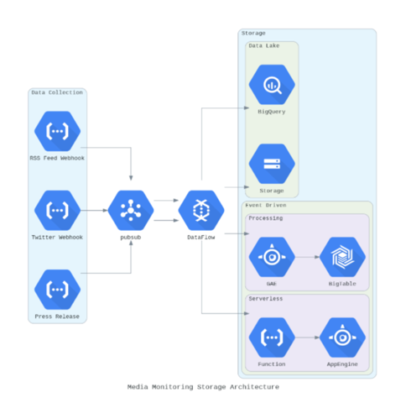

  - SUBSYSTEM SERVICES

It provides comprehensive subsystem overview dashboards. You can get an overall health status of the monitored subsystem and thus quickly and easily identify the abnormal situations.

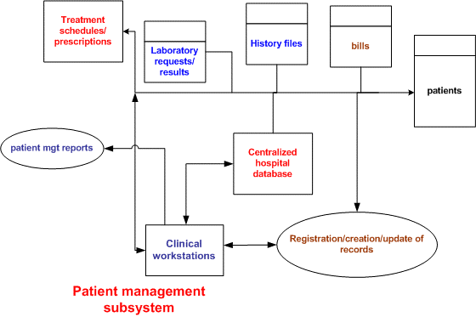
It can be pinpointed to the following:

⦁ Time-saving Technology
⦁ Improved Efficiency by avoiding human errors
⦁ Reduces scope for Error
⦁ Data security and correct data retrieval made possible
⦁ Cost effective and easily manageable
⦁ Easy access to patient data with correct patient history
⦁ Improved patient care made possible
⦁ Easy monitoring of supplies in inventory
⦁ Reduces the work of documentation
⦁ Better Audit controls and policy compliance.

  - USER INTERFACE DESIGNS

1. Dashboard Main Page
This main page is the first thing that we will see before entering patient data, so we made this dashboard simpler by including the registration form elements inside the pop up accessible by clicking “Add Patient” button.
2. Patient Registration Flow
In this new design, our team put the patient registration form in a pop up so that the initial appearance looks neater and the nurse can focus more on entering new patient data.
Final Word
hopefully, can be useful to readers by glancing at the UI / UX design flow that I usually use in every project or my design work.

  - SUMMARY

1- The data in the datasets in never 100% accurate, there are always some garbage values that throw of exceptions in the program, so had to remove those.
2- Could not test the data on large datasets due to system restrictions.
3- Had to work with a public predefined dataset and could not test on Real-time dataset, but it should work fine on re-rendering the dashboard.
4- Had to use downloaded datasets as using from server was causing work to slow down..

CHAPTER-5

TECHNICAL IMPLEMENTATION & ANALYSIS

  - OUTLINE

An interactive dashboard using Python(Streamlit, numpy , pandas) to easily collect and show all the details of a patient saved across various datasets in one place. This can help the patients and their caretakers to easily access the data regarding patient and take better care of them.

  - TECHNICAL CODING AND CODING SOLUTION

Source code

import streamlit as st
import pandas as pd
import numpy as np

st.title("Patient DashBoard")
st.sidebar.title("DashBoard")
st.sidebar.markdown("All the required details at one place.")

#--------------------------------------------DATA IMPORTING START------------------------------------------------------------------#
@st.cache(persist=True)
@st.cache(allow_output_mutation=True)
def load_details():
details=pd.read_csv("../WebApp/csv/patients.csv")
return (details)
patient_details=load_details()

def load_observations():
details=pd.read_csv("../WebApp/csv/observations.csv")
return (details)
patient_observations=load_observations()

def load_condition():
details=pd.read_csv("../WebApp/csv/conditions.csv")
return (details)
patient_conditions=load_condition()

def load_allergies():
details=pd.read_csv("../WebApp/csv/allergies.csv")
return (details)
patient_allergies=load_allergies()

def load_careplans():
details=pd.read_csv("../WebApp/csv/careplans.csv")
return (details)
patient_careplans=load_careplans()

def load_devices():
details=pd.read_csv("../WebApp/csv/devices.csv")
return (details)
patient_devices=load_devices()

def load_suppliers():
details=pd.read_csv("../WebApp/csv/providers.csv")
return(details)
suppliers=load_suppliers()

#-------------------------------------------------DATA IMPORTING END----------------------------------------------------------------#

#----------------------------------------------------DATA CLEARING START------------------------------------------------------------#
patient_details['PREFIX'] = patient_details['PREFIX'].str.replace('\f+',' ')
patient_details['MAIDEN'] = patient_details['MAIDEN'].str.replace('\f+','')

index=0
for i in patient_details["PREFIX"]:
if not(isinstance(i, str)):
patient_details["PREFIX"][index]=''
index=index+1

index=0
for i in patient_details["FIRST"]:
patient_details["FIRST"][index]=''.join([i for i in i if not i.isdigit()])
index=index+1;

index=0
for i in patient_details["LAST"]:
patient_details["LAST"][index]=''.join([i for i in i if not i.isdigit()])
index=index+1;

index=0
for i in patient_details["MAIDEN"]:
if (isinstance(i, str)):
patient_details["MAIDEN"][index]=''.join([i for i in i if not i.isdigit()])
else:
patient_details["MAIDEN"][index]=''
index=index+1;

index=0
for i in patient_details["MARITAL"]:
if(i=="M"):
patient_details["MARITAL"][index]="Marrried"
elif(i=="S"):
patient_details["MARITAL"][index]="Single"
elif(i==''):
patient_details["MARITAL"][index]="N/A"
index=index+1;

index=0
for i in patient_details["GENDER"]:
if(i=="M"):
patient_details["GENDER"][index]="Male"
if(i=="F"):
patient_details["GENDER"][index]="Female"
index=index+1;

#----------------------------------------------------DATA CLEARING END--------------------------------------------------------------#

#------------------------------------------Display Function---------------------------------------------#

def main_display():
st.sidebar.subheader("Patient Details to Display:")
choice = st.sidebar.radio('', ('Personal Details', 'Patient Obsevations', 'Patient Allergies' , 'Patient Conditions' , 'Monitoring Devices'))
if(choice=='Personal Details'):
st.write("\n")
st.subheader("Personal Details of the Patient-")
index=-1
for i in patient_details["Id"]:
index=index+1
if patient_id==i:
st.write("Address of the patient: "+patient_details["ADDRESS"][index]+", "+patient_details["CITY"][index]+", "+patient_details["STATE"][index]+", "+patient_details["COUNTY"][index])
st.write("Zip Code-"+str(patient_details["ZIP"][index]))
st.write("Gender of the patient: "+patient_details["GENDER"][index])
st.write("Race of the patient: "+patient_details["RACE"][index])
st.write("Ethnicity of the patient: "+patient_details["ETHNICITY"][index])
#st.write("Marital Status of patient: "+patient_details["MARITAL"][index])

if(choice=='Patient Obsevations'):
st.write("\n")
st.subheader("Medical Details of the Patient-")
index=0
reading=0
st.markdown("#### Observation:"+str(reading+1))
reading=reading+1
for i in patient_observations["PATIENT"]:
if patient_id==i:
if(patient_observations["DESCRIPTION"][index]!='QOLS')and(patient_observations["DESCRIPTION"][index]!='DALY')and(patient_observations["DESCRIPTION"][index]!="QALY"):
if("/uL" in str(patient_observations["UNITS"][index])):
st.write(patient_observations["DESCRIPTION"][index]+": "+str(patient_observations["VALUE"][index])+" x "+str(patient_observations["UNITS"][index]))
else:
st.write(patient_observations["DESCRIPTION"][index]+": "+str(patient_observations["VALUE"][index])+""+str(patient_observations["UNITS"][index]))

if(patient_observations["DESCRIPTION"][index]=="Tobacco smoking status NHIS"):
st.markdown("#### Observation:"+str(reading+1))
reading+=1
index=index+1

if(choice=='Patient Allergies'):
st.write("\n")
st.subheader("Allergies suffered by the Patient-")
index=0
found=0
for i in patient_allergies["PATIENT"]:
if patient_id==i:
st.write(str(patient_allergies["DESCRIPTION"][index]))
found=1
index=index+1

if found==0:
st.write("No Allergies to Report.")
else:
st.markdown("### Take care of these while interacting with Patient")

if(choice=='Patient Conditions'):
st.write("\n")
st.subheader("Patient is suffering from:")
index=0
for i in patient_conditions['PATIENT']:
if patient_id==i:
st.write(patient_conditions['DESCRIPTION'][index])
index=index+1

index=0
st.subheader("Patient's careplan to Keep in Mind-:")
for i in patient_careplans['PATIENT']:
if i==patient_id:
st.write(patient_careplans['DESCRIPTION'][index])
index=index+1

if(choice=='Monitoring Devices'):
st.write("\n")
st.subheader("Monitoring devices/Implants for the Patient")
index=0
found=0
for i in patient_devices['PATIENT']:
if i==patient_id:
st.write("Device: "+patient_devices['DESCRIPTION'][index])
st.write("Device id:"+patient_devices['UDI'][index])
found=1
index=index+1
if found==0:
st.write("No Implants/Devices for the Patient.")

#------------------------------------------------------------------------------------------------------------#
#---------------------------------------------------Final working-------------------------------------------------------------------#
patient_id = st.text_input("ENTER THE PATIENT ID:")

if(patient_id!=""):
st.markdown("#### Patient ID: "+ patient_id)
index=-1;
for i in patient_details["Id"]:
index=index+1
if patient_id==i:
st.markdown("#### Patient Name: "+patient_details["PREFIX"][index]+" "+patient_details["FIRST"][index]+" "+patient_details["LAST"][index]+" "+patient_details["MAIDEN"][index])
main_display()
else:
st.markdown("#### Patient ID: ")
st.markdown("#### Patient Name: ")
choice = st.sidebar.radio('', ('Personal Details', 'Patient Obsevations', 'Patient Allergies' , 'Patient Conditions' , 'Monitoring Devices'))
if(choice=='Personal Details'):
st.write("\n")
st.subheader("Personal Details of the Patient-")

if(choice=='Patient Obsevations'):
st.write("\n")
st.subheader("Medical Details of the Patient-")

if(choice=='Patient Allergies'):
st.write("\n")
st.subheader("Allergies suffered by the Patient-")

if(choice=='Patient Conditions'):
st.write("\n")
st.subheader("Patient is suffering from-")

if(choice=='Monitoring Devices'):
st.write("\n")
st.subheader("Monitoring devices/Implants for the Patient-")

st.sidebar.subheader("Medical Suppliers Loacations")
if st.sidebar.checkbox("Show", True, key='1'):
st.subheader("Locations of Medical Suppliers in Massachusetts")
st.map(suppliers)

Website Link: https://patient-dashboard-streamlit.herokuapp.com/

SOME PATIENT ID’S:-

- 76982e06-f8b8-4509-9ca3-65a99c8650fe
ad2e9916-4979-40fc-a8c0-68651a0cb5a6
518f83f3-a717-4705-a181-06e205df480b

  - FLOW DIAGRAM

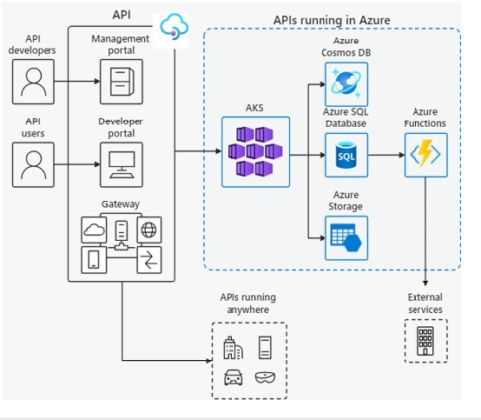

  - OUTPUT OF THE SOURCE CODE

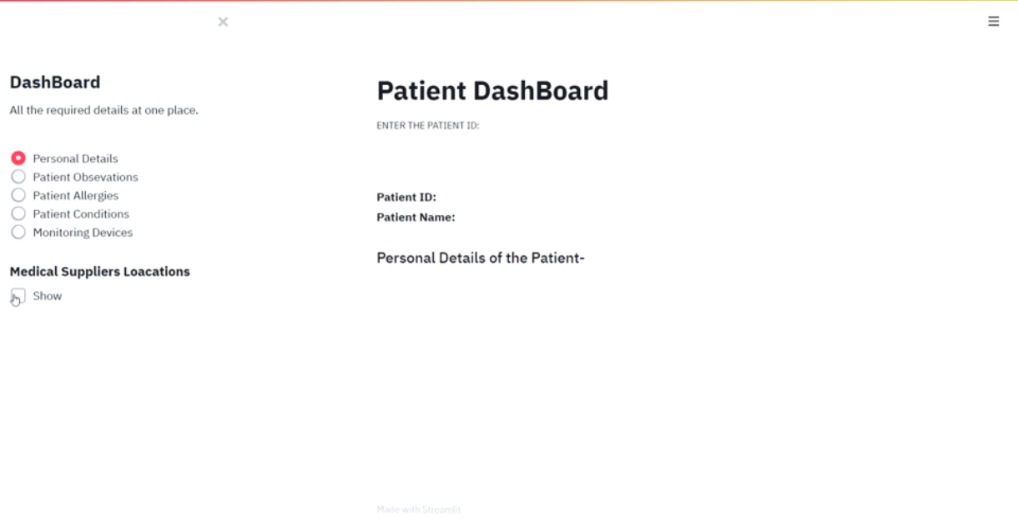
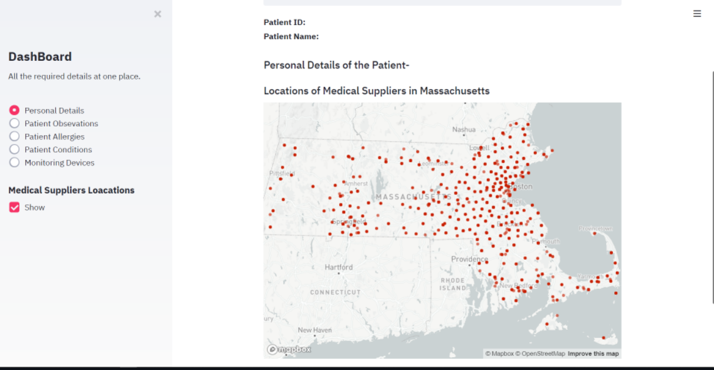

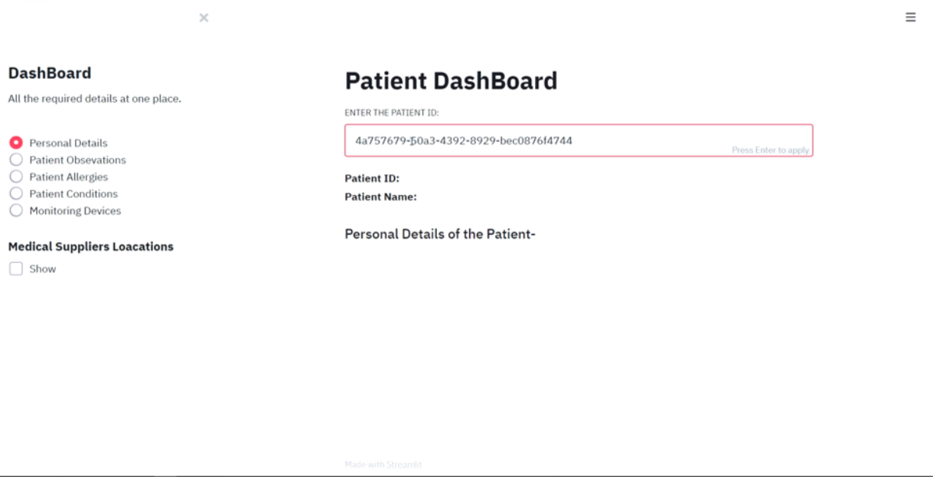

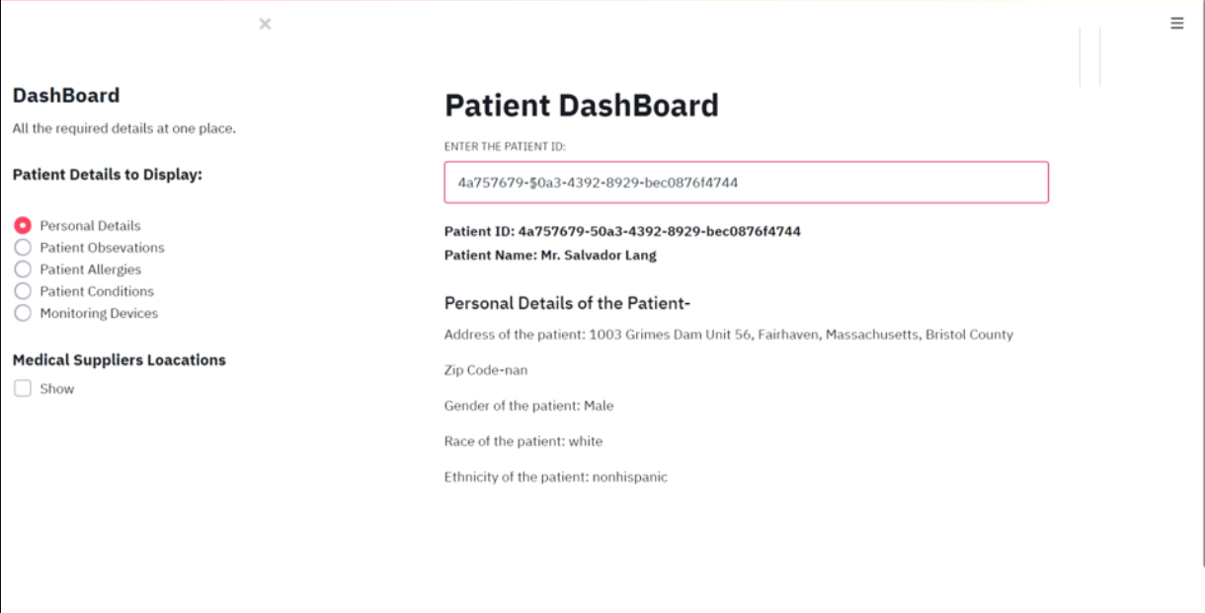

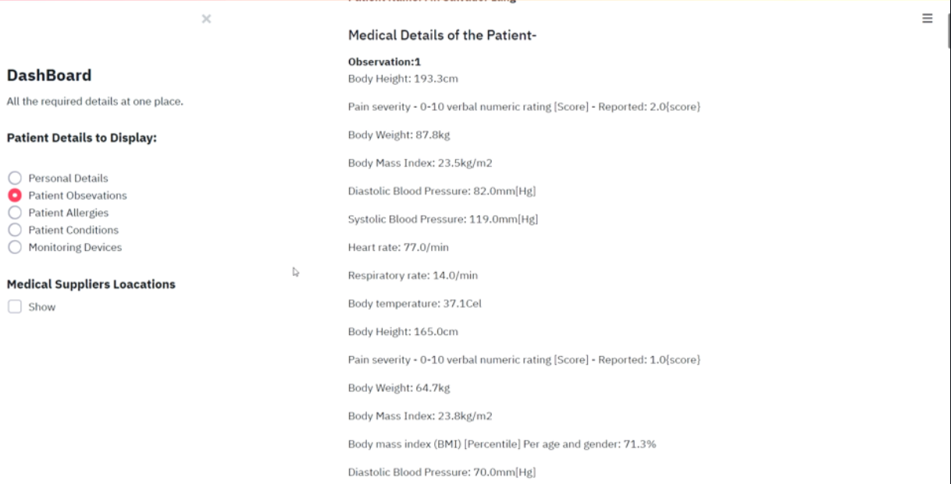

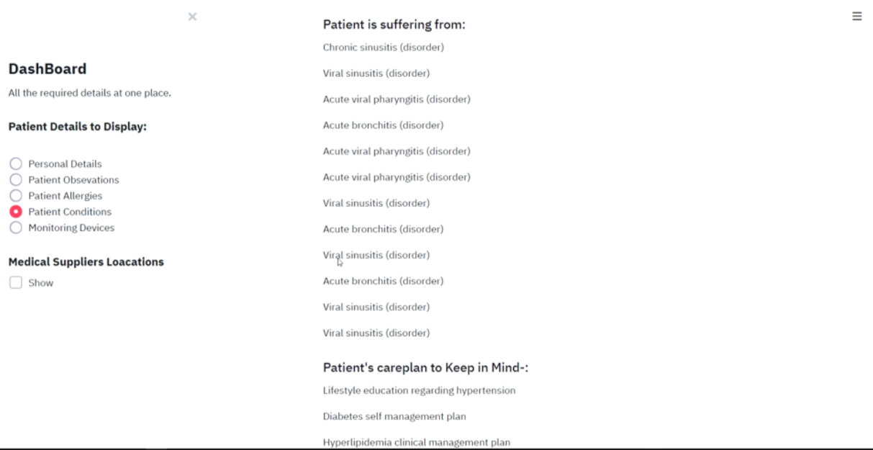

  - PERFORMANCE ANALYSIS

Analysis is a detailed of the various operation performed by the system and the relationship exist between the system. In our project we analysed the relationship that we will be using in our project.

PATIENT
PATIENT DASHBOARD SERVER
HOSPITAL/
DOCTOR

As soon as the patient opens the patient dashboard (https://patient-dashboard-streamlit.herokuapp.com/), the login page is displayed to the patient where he/she is asked to enter patient Id (For example, 76982e06-f8b8-4509-9ca3-65a99c8650fe),then a page is displayed where the patient can access all the details regarding their medical reports, allergies, prescriptions, vital observation reports, location of medical stores ,etc. which are uploaded/updated here by the doctor or the hospital management.

CHAPTER-6
PROJECT OUTCOME AND APPLICABILITY

  - OUTCOME

This dashboard uses the various datasets containing data of various patients as per different categories, goes through them and generates a complete report of a specific patient and displays them in a organized way so that it can be easily understood by patient caretakers.

  - KEY IMPLEMENTATIONS OUTLINES OF THE SYSTEM

The difficulty of managing patient recruitment and documentation for clinical trials prompts a demand for instruments for closely monitoring these critical but unpredictable processes. Increasingly adopted Electronic Data Capture applications provide novel opportunities to reutilize stored information for an efficient management of traceable trial workflows. In related clinical and administrative settings, so-called digital dashboards that continuously visualize time-dependent parameters have recently met a growing acceptance. To investigate the technical feasibility of a study dashboard for monitoring the progress of patient recruitment and trial documentation, we set out to develop a propositional prototype in the form of a separate software module.

• Enrollment into clinical trials requires careful monitoring and management.
• Widely used digital dashboards continuously visualize time-dependent parameters.
• We designed a prototypical study dashboard for trial recruitment and documentation.
• Experts commented that the dashboard allowed detecting whether something was amiss.

  - SIGNIFICANT PROJECT OUTCOMES

Though healthcare organizations may vary in size, there are several stakeholders common to every hospital. Each of them requires real-time data to be able to not only perform their daily functions but also to find out how to make things better:
Hospital Administration
These guys need to see the whole picture in one place – how the system works at each level. Healthcare dashboard metrics allow them to track the performance of the hospital – both in terms of commercial efficiency (like costs and the number of admissions) and in terms of treatment success rates (LOS, diagnosis by department, etc.). Knowing where problems and potential areas for innovation allow them to make better decisions, improve the quality of care, provide more efficient resource management, lower costs and optimize workloads.
Medical Staff
Data analysis is critical in evidence-based medicine. Doctors are trained from clinical data. They are taught to analyze patient therapies based on data in medical books. So a single dashboard containing all patient data is a convenient tool to track the effectiveness of treatments and to compare the work of clinicians with their colleagues. This is an effective way to enhance clinician performance as well as patient satisfaction.
Government/Federal Organizations
These organizations need to track the quality and safety of healthcare organization operations, their financial rankings and credit ratings. Here healthcare dashboards are used to monitor how healthcare systems stack up against one another.
Patients and Their Families
These stakeholders need transparency and information consolidation. A dashboard with a user-friendly interface can help them select a hospital or track treatment progress, which also enhances patient satisfaction.

  - PROJECT APPLICABILITY ON REAL WORLD APPLICATIONS

While many hospitals keep their data close to the vest to protect patient privacy, we were able to find two great dashboard examples in healthcare that your facility can learn from:

#1: Virginia Commonwealth University Health System (VCUHS)

VCUHS implemented a clinician safety dashboard to address issues of preventable medical errors. In short order, the dashboard proved its worth by helping the health system meet its goal of having zero events of preventable harm. It also helped improve other metrics, such as vaccine administrations, and infection and fall rates. The dashboard was successfully adopted by nurses, care partners, and physicians, reducing their reliance on memory by providing a wealth of information in a central location.
#2: Rush University Medical Center

Rush uses a surgery outcomes dashboard. Similar to the clinician dashboard, this tool highlights departmental operations to evaluate performance. Looking at the dashboard, it’s easy to see how Rush benchmarks against other providers and the entire industry. This provides valuable perspective—numbers without context can mean very little.

CHAPTER-7

CONCLUSIONS & RECOMMENDATION

  - OUTLINE

While there’s no end-all, be-all healthcare dashboard template, there are common types of dashboards your facility can put into play to aid strategic decision-making. As long as your dashboards aid in comprehension and analysis of the big data flowing through your system, you’re headed in the right direction.

  - LIMITATIONS/CONSTRAINTS OF THE SYSTEM

A customized dashboard will not work well if the users of the dashboard are exploring ways to have access to their data online and are unclear about what they need. Customized dashboards work best when the users of the dashboard have been fully consulted and there is a broad agreement in terms of what it contains, how it is accessed and how data is viewed and interrogated. There is often a need to show the same data in different ways or to different levels of detail for different types of user. This means that user groups have to be identified so that the dashboard is relevant to each group – what each user group sees can be controlled by login or some other mechanism. Where there is a lack of clarity about what the users want, a customized dashboard can be the wrong route.
For today’s data-driven companies, there are thousands of metrics that can be gathered and collected to gain insights into business performance. As relevant data points grow exponentially, it becomes challenging to use traditional dashboards to track these metrics and make informed timely decisions. Here are some of the most significant limitations of conventional BI dashboards:
Lack of real-time anomaly detection prevents proactive incident management

⦁ Over-reliance on historical data
⦁ Missing small incidents that have a negative impact
⦁ Cluttered dashboards and false positives
⦁ Lack of intelligent prioritization
⦁ Leverage the Power of AI Analytics

  - FUTURE ENHANCEMENT

There are lot of improvement that can be made to this project to become a great solution. Firstly, The Dataset needs to be constantly updated with data logs from Monitoring devices/implants so Hospitals can use databases like Data Stix ,MySQL to store data from where it is much easier to insert and extract data.
Secondly, The Dash Board server needs to be deployed on a Cloud service as the real-world dataset would be quite huge far beyond device capacities and dashboard needs to constantly ping the DB for new data.
Thirdly, A feature should be added to alert the hospital as well as the caretakers(via dashboard notification) if there is a sudden spike in the vitals of the patient, so that immediate help can be given and medical services dipatched immediately without wasting a second. and many more!!!

REFERENCES
  - https://www.udemy.com/course/the-complete-guide-to-angular-2/
  - https://medium.com/dsc-vit-bhopal/how-the-internet-works-http-concept-a5c08b4234b2
  - https://getbootstrap.com/docs/5.1/getting-
  - https://medium.com/dsc-vit-bhopal/how-the-internet-works-http-concept-a5c08b4234b2
  - https://www.geeksforgeeks.org/web-development
  - https://rapidapi.com/hub
  - https://www.boldbi.com/dashboard-examples/healthcare/patient-monitoring-dashboard

